Bachelor or Master Thesis

# Efficient Bloom Filter Processing on new Hardware

Are you looking for a Bachelor or Master thesis in advanced computer science and hardware oriented programming? Are you interested in data storage technologies? Do you want to get experience in the emerging field of fast databases and are you interested in defining new standards?

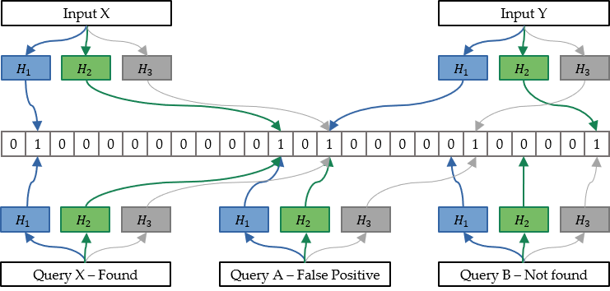

We look forward to you joining us as a Bachelor or Master Thesis student (d/f/m) within the Big Geospatial Data Management Group at the Department for Aerospace and Geodesy, TUM School of Engineering and Design. A Supervision in the School of Computation, Information and Technology is also possible.

Location: Ottobrunn/Munich/Remote

Duration: 3 to 6 months depending on your study program

Your topic:

Bloom filters are one of the most used data structures in databases to approximately represent sets and are used for various applications ranging from pure indexing to efficient merging. Up to now they are mainly calculated on general purpose CPUs. With current trends on specified hardware for new tasks it is prevalent to research on possible implementation improvements on specialized hardware like GPUs and FPGAs. With this thesis you investigate potential advantages of different hardware realizations of Bloom Filters including efficient hashing algorithms on GPUs and FPGAs. This should mainly answer the question: How to speed up Bloom filters and Bloom filter variants with new hardware?

This may include:

* Literature Review of Bloom Filter implementations on different hardware.
* Development in hardware-oriented settings on GPUs and FPGA.
* Benchmarking the newly developed approach against the state of the art.
* Application of the approaches in geodata-related applications.

Related Work:

Fluid Co-processing: GPU Bloom-filters for CPU Joins ([Gubner et al 2019](https://ir.cwi.nl/pub/28790/28790.pdf))

[BitBlender: Scalable Bloom Filter Acceleration on FPGAs with Dynamic Scheduling (Liu et al 2024)](https://ieeexplore.ieee.org/document/10705574)

Hardware-oriented optimization of Bloom filter algorithms and architectures for ultra-high-speed lookups in network applications ([Sateesan et al 2022](https://www.sciencedirect.com/science/article/abs/pii/S0141933122001582))

High-Performance Filters for GPUs ([McCoy et al 2023](https://dl.acm.org/doi/10.1145/3572848.3577507))

Qualifications:

* Interest in emerging field of Big (Geospatial) Data
* Advanced programming skills (preferably C / C++, alternatively Python, Rust)
* Experience with Databases and Data Management
* Experiences with FPGA/GPU programming
* Interest and experience in literature-based work with a good scientific practice
* Enrolled full time student within Computer Science, Electrical Engineering, Geo Informatics or similar field of study
* Fluent English is mandatory; German would be an asset

Applications via Mail with CV and transcript to:

|  |  |
| --- | --- |
| Advisor: | M.Sc. Paul Walther |
| Raum: | 9377.01.113 |
| Telefon: | 089/289-555 59 |
| Email: | paul.walther@tum.de |